LAB 9

NAYAKANTI SAI MIHIRNATH

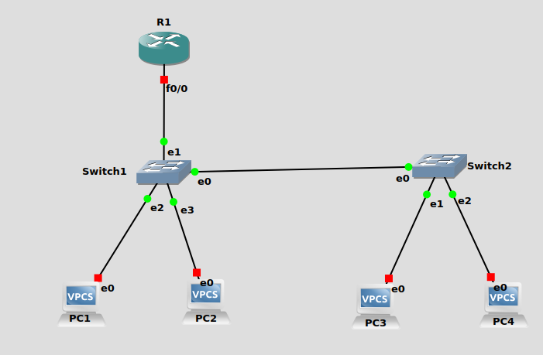

Configuring R1 : -

conf t

int f0/0
ip address 10.0.0.1 255.0.0.0
no shut
exit

int f0/0.11
encapsulation dot1q 11
ip address 192.168.1.126 255.255.255.192
no shut
exit

int f0/0.22
encapsulation dot1q 22
ip address 192.168.1.254 255.255.255.128
no shut
exit

ip dhcp pool VLAN1
network 192.168.1.64 255.255.255.192
default-router 192.168.1.126
exit

ip dhcp pool VLAN2
network 192.168.1.128 255.255.255.128
default-router 192.168.1.254
exit

Capture of pings from PC1 to all PC’s
